**QSMART – COOLING GROUP TEST & CLOSING PROCEDURE**

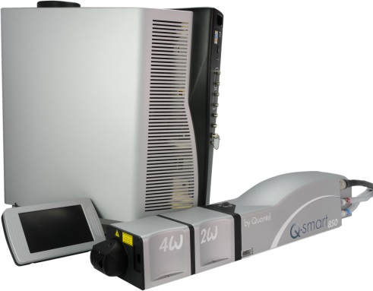

**Toolkit:**

Allen keys

**System**: QSMART

**Purpose:** This document details how to test and close the Cooling Group assembly

|  |  |  |
| --- | --- | --- |
| Revision | date | modification |
| Initial issue | July 4, 2014 |  |
|  |  |  |
|  |  |  |
|  |  |  |

# TEST AND CLOSING

Reinstall the CG into the ICE and fasten with 3 screws 4x12 BHC black (3/E13/0600).

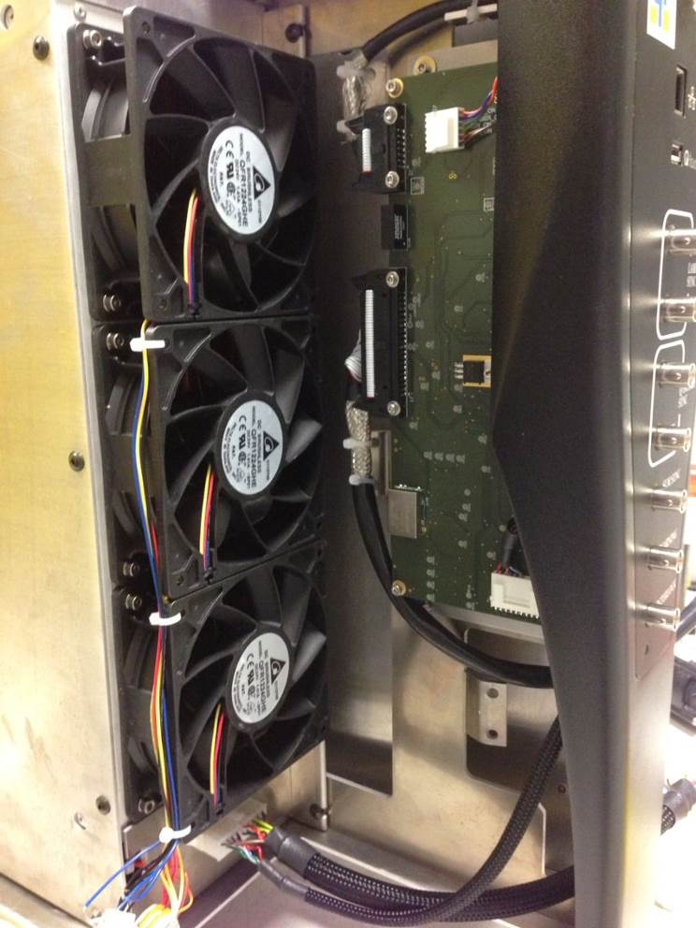

* Connect the laser head and check that there is no water leakage
* Remove the CG to close it.

# Emptying and closing

|  |  |  |
| --- | --- | --- |
| 9.00 | V/BHC-M0310A4 | BHC M3-10 INOX A4 |
| 3.00 | 3/E13/0600 | BLACK BHC FLANGED M4 SCREW |

Drain the CG (for transport) by connecting this equipment to the drain connector opening the cap.

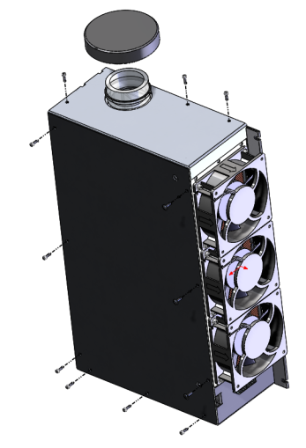

1-Close CG-1 with the locking plate and 9 screws BHC M3x10.

2- Fix the heat exchanger with 3 black screws BHC

3- Screw the cap on the tank

3 black screws BHC